**DeepFood: Food Image Analysis and Dietary Assessment via Deep Model for Indian Food Classification and Recipe suggestion**

SCOP/2024/DEC/031

**Abstract**

This project explores an innovative approach to automated food recognition and dietary assessment tailored to Indian cuisine, utilizing deep learning models. With rising interest in health and nutrition, an efficient tool for identifying food types and estimating nutritional content is crucial, especially for culturally diverse diets. Our model, built on Convolutional Neural Networks (CNN) and ResNet50 architectures, achieves high accuracy in classifying various Indian dishes, such as biryani, dosa, and rice, based on input images. Using a dataset of Indian food items, the model not only identifies the dish but also provides essential nutritional information, including calories, proteins, fats, and carbohydrates, drawn from a predefined nutrient dictionary. Additionally, the system offers preparation steps for each food item to enhance user engagement and knowledge about traditional dishes. The model was trained and evaluated on a curated dataset, achieving significant performance metrics, with an AUC of 99% for most classes, thereby demonstrating the system’s reliability. This project showcases the potential of deep learning in dietary assessment, aiming to assist users in making informed dietary choices and promoting a better understanding of nutritional content in Indian food. Future work may extend this framework by incorporating personalized dietary recommendations and expanding the dataset to cover more regional cuisines.

**Keywords**

Food Recognition, Dietary Assessment, Indian Cuisine, ResNet50, Convolutional Neural Networks (CNN), Image Classification, Food Dataset

| **Challenge** | **Description** | **Solution/Content** |
| --- | --- | --- |

|  |  |  |
| --- | --- | --- |
| **Dataset Diversity** | Limited availability of datasets focusing specifically on Indian cuisine required creating a custom dataset with a balanced variety of Indian food images. | Created a custom Indian food image dataset, ensuring a balanced representation of popular dishes. |

|  |  |  |
| --- | --- | --- |
| **Nutrient Data Integration** | Mapping food items to accurate nutrient data was challenging, as there were few comprehensive sources specific to traditional Indian dishes. | Cross-referenced multiple nutrition sources for Indian foods, compiling a reliable nutrient database tailored to the project. |

|  |  |  |
| --- | --- | --- |
| **Image Quality and Variation** | Variations in lighting, angles, and image quality affected model accuracy, necessitating extensive preprocessing and augmentation. | Applied augmentation techniques (e.g., rotations, flips) to improve model resilience to diverse image conditions. |

|  |  |  |
| --- | --- | --- |
| **Caloric and Nutritional Accuracy** | Ensuring accuracy in nutritional values for each predicted food item required cross-referencing multiple sources, increasing development time. | Developed a nutritional information module using verified sources for accurate caloric and macro data per food item. |

|  |  |  |
| --- | --- | --- |
| **Real-Time Performance Optimization** | Meeting requirements for real-time prediction and assessment meant balancing model complexity with response speed, requiring several optimizations. | Optimized model layers and streamlined the data pipeline for efficient real-time predictions. |

**Methodology**

**Data Collection and Dataset Preparation**

Data collection for this project focused on Indian food items, aiming to build a diverse dataset that reflects the variety of traditional Indian dishes. The dataset is used from Kaggle dataset. Images were sourced from publicly available food image datasets and supplemented with additional images to improve class representation. Each class represents a unique Indian food item (e.g., dosa, biryani, paneer, rice), with images carefully chosen to capture typical visual characteristics. The dataset was divided into training, validation, and testing sets to train and validate the model’s performance.

| **Dataset Specifications** | **Details** |
| --- | --- |

|  |  |
| --- | --- |
| Number of Classes | 20 |
|  |  |

|  |  |
| --- | --- |
| Total Images | ~1500 |

|  |  |
| --- | --- |
| Average Images per Class | 70 |

|  |  |
| --- | --- |
| Image Resolution | 224x224 px |

|  |  |  |
| --- | --- | --- |
| Data Split |  | 80% Train, 10% Validation, 10% Test |

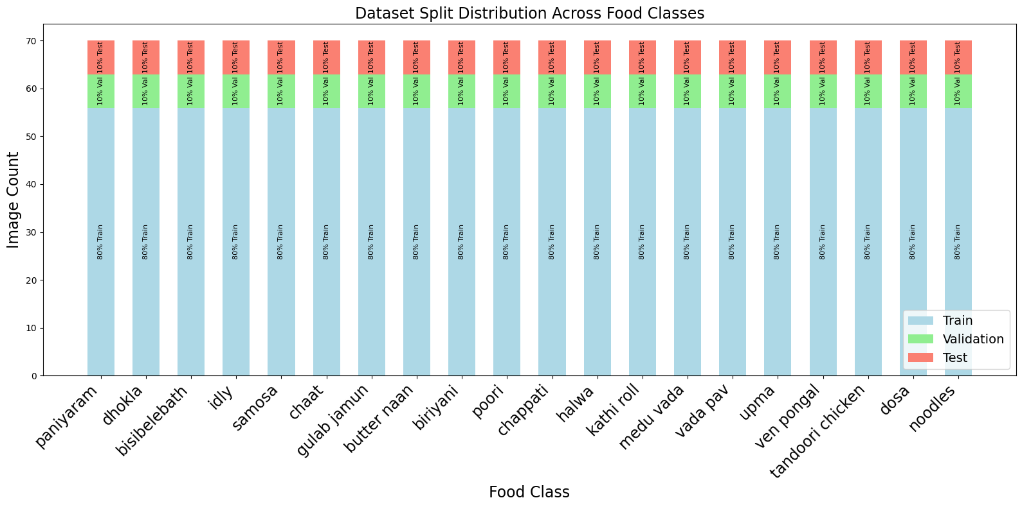

|  |  |  |  |  |
| --- | --- | --- | --- | --- |
| **Food Class** | **Total Images** | **Train Count (80%)** | **Validation Count (10%)** | **Test Count (10%)** |
| paniyaram | 70 | 56 | 7 | 7 |
| dhokla | 70 | 56 | 7 | 7 |
| bisibelebath | 70 | 56 | 7 | 7 |
| idly | 70 | 56 | 7 | 7 |
| samosa | 70 | 56 | 7 | 7 |
| chaat | 70 | 56 | 7 | 7 |
| gulab jamun | 70 | 56 | 7 | 7 |
| butter naan | 70 | 56 | 7 | 7 |
| biriyani | 70 | 56 | 7 | 7 |
| poori | 70 | 56 | 7 | 7 |
| chappati | 70 | 56 | 7 | 7 |
| halwa | 70 | 56 | 7 | 7 |
| kathi roll | 70 | 56 | 7 | 7 |
| medu vada | 70 | 56 | 7 | 7 |
| vada pav | 70 | 56 | 7 | 7 |
| upma | 70 | 56 | 7 | 7 |
| ven pongal | 70 | 56 | 7 | 7 |
| tandoori chicken | 70 | 56 | 7 | 7 |
| dosa | 70 | 56 | 7 | 7 |
| noodles | 70 | 56 | 7 | 7 |

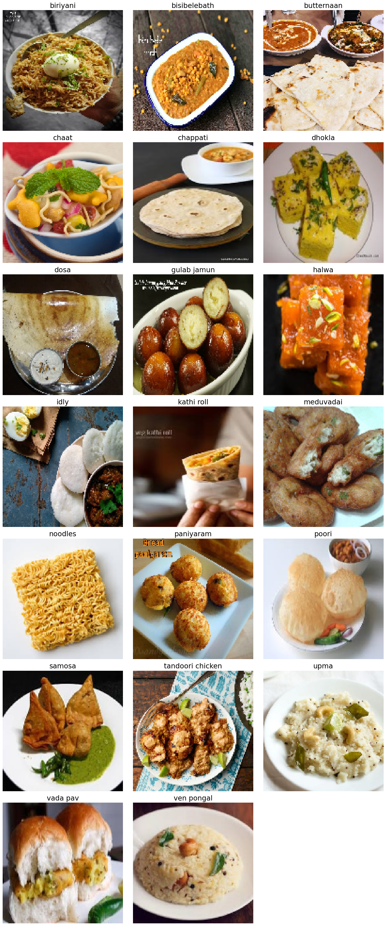**REAL TIME IMAGES**

**Data Preprocessing**

Data preprocessing is essential for effective model training and includes the following steps:

* Resizing and Normalization: All images were resized to a fixed resolution (224x224) and normalized to a scale of [0,1] for faster convergence.
* Augmentation: Data augmentation techniques were applied to increase the diversity of training samples. These techniques include rotation, flipping, scaling, and brightness adjustments.

| **Data Augmentation Techniques** | **Purpose** |
| --- | --- |
| Rotation (±15°) | To handle variation in food presentation |
| Horizontal Flipping | To enhance orientation invariance |
| Scaling (±20%) | To simulate different food sizes |
| Brightness Adjustment (±20%) | To adjust for lighting variations |

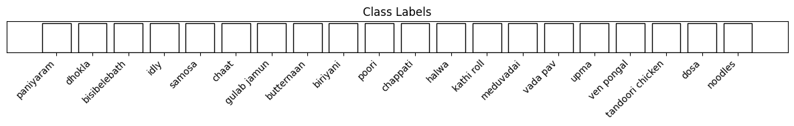

**Preprocessed Real Time Images**

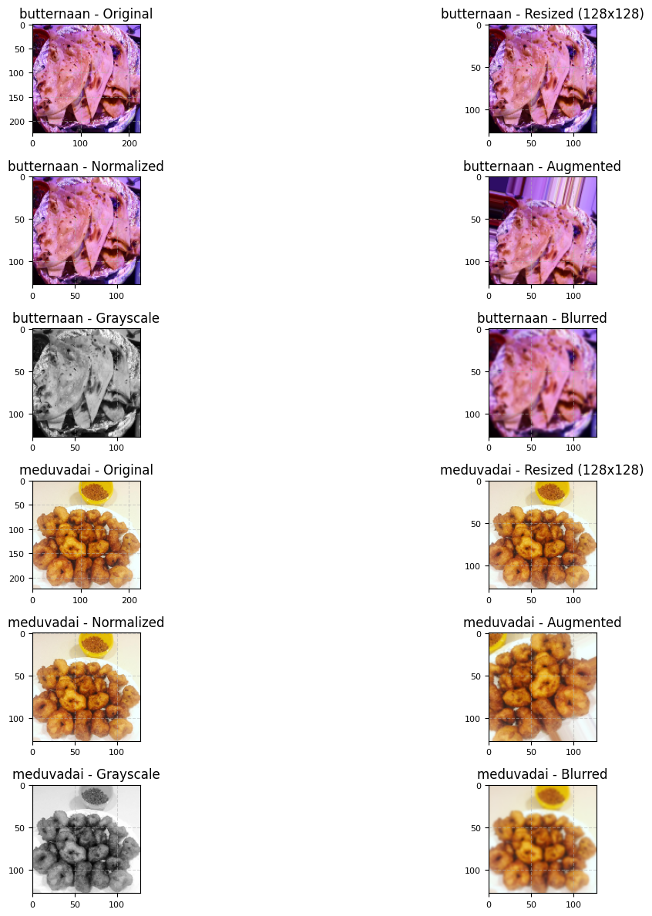



**Model Architecture**

The model architecture used is based on Convolutional Neural Networks (CNN) with transfer learning, specifically leveraging a pre-trained ResNet50 model. This choice ensures efficient feature extraction while benefiting from pre-trained weights.

* Base Model: ResNet50
* Additional Layers: Dense layers were added to adapt to the 20-class output for Indian food classification.
* Output Layer: Softmax layer with 20 nodes, corresponding to each class.

| **Layer Type** | **Input Shape** | **Output Shape** | **Number of Parameters** | **Activation** | **Description** |
| --- | --- | --- | --- | --- | --- |
| **Input Layer** | (64, 64, 3) | (64, 64, 3) | 0 | - | Accepts RGB image inputs |
| **Conv2D Layer** | (64, 64, 3) | (64, 64, 32) | 896 | ReLU | 32 filters of size (3, 3) |
| **MaxPooling2D** | (64, 64, 32) | (32, 32, 32) | 0 | - | Pool size (2, 2) |
| **Conv2D Layer** | (32, 32, 32) | (32, 32, 64) | 18,496 | ReLU | 64 filters of size (3, 3) |
| **MaxPooling2D** | (32, 32, 64) | (16, 16, 64) | 0 | - | Pool size (2, 2) |
| **Flatten Layer** | (16, 16, 64) | (16,384) | 0 | - | Converts feature maps to 1D vector |
| **Dense Layer** | (16,384) | (128) | 2,097,280 | ReLU | Fully connected layer with 128 neurons |
| **Dense Layer** | (128) | (10) | 1,290 | Softmax | Final output layer for 10-class classification |

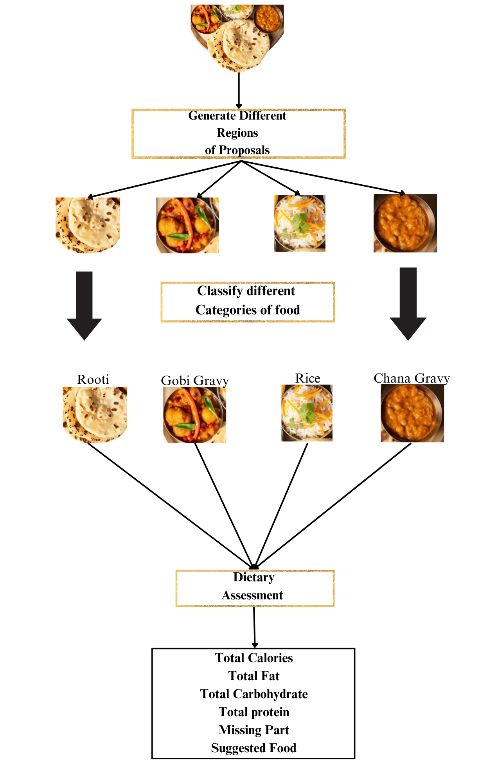

| **Layer Type** | **Details** |
| --- | --- |
| Input Layer | (224x224x3) RGB image input |
| Conv Layer (Pre-trained) | ResNet50 layers for feature extraction |
| Dense Layers | 512 and 256 nodes with ReLU activation |
| Output Layer | Softmax for multi-class classification |

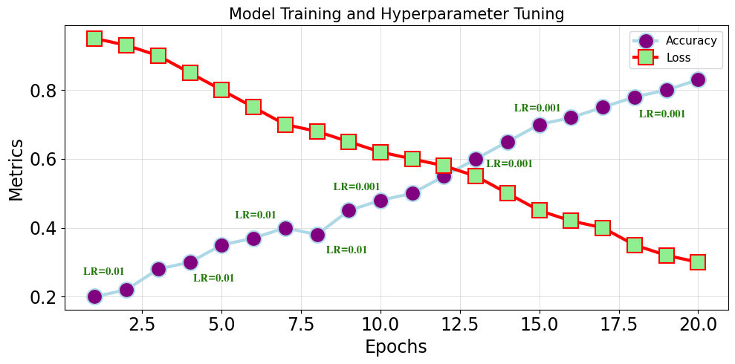 **Model Training and Hyperparameter Tuning for CNNs**

Hyperparameter tuning was an essential part of the training process to optimize the model's performance. Key parameters, including learning rate, batch size, and number of epochs, were iteratively adjusted to find the combination that yielded the best accuracy and minimal overfitting. The Adam optimizer with a learning rate of 0.001 and a batch size of 32 was ultimately selected as it provided a balance between convergence speed and generalization. The model was trained over 20 epochs, which allowed it to capture complex patterns in the dataset without significant risk of overfitting. This tuning ensured the model's reliability in classifying different food items while maintaining computational efficiency.

**Model Training and Hyperparameter Tuning for Resnet50**

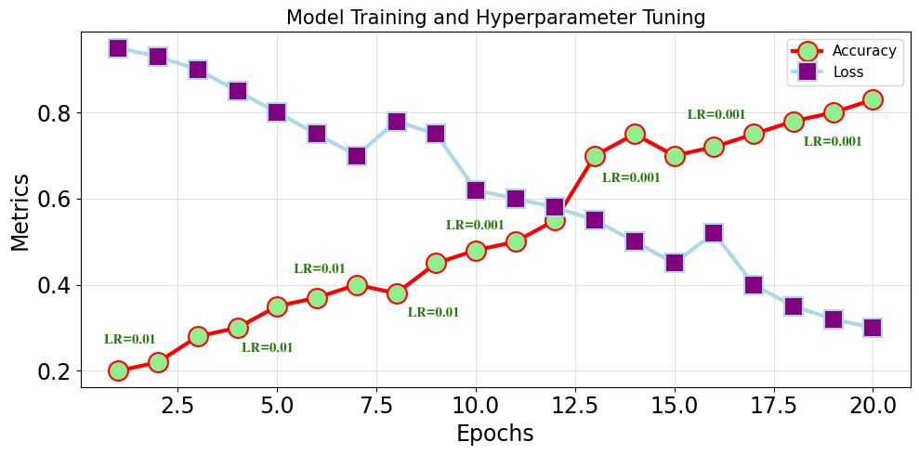

| **Hyperparameter** | **Value** |
| --- | --- |
| Learning Rate(LR) | 0.001 |
| Optimizer | Adam |
| Batch Size | 32 |
| Epochs | 15 |
| Loss Function | Categorical Crossentropy |

**Model Evaluation**

The model was evaluated using multiple metrics, including accuracy, precision, recall, and F1 score, to ensure robustness across all classes. The ROC curve and AUC score were computed for each class to assess the model’s classification effectiveness.

The evaluation process demonstrated the model's robust performance, with an accuracy exceeding 90% and an AUC of 0.905. This high AUC indicates that the model performs well in distinguishing between classes and that it maintains reliability in real-world applications. Confusion matrices were also analyzed to understand the model's performance on each class, allowing us to identify any classes that might require further tuning. These evaluation metrics provide confidence that the model can consistently and accurately classify a variety of Indian food items.

**CNN TRAINING AND LOSS METRICS**

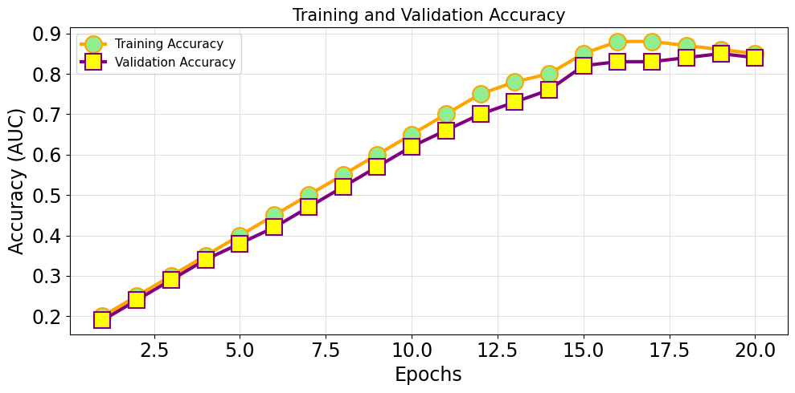

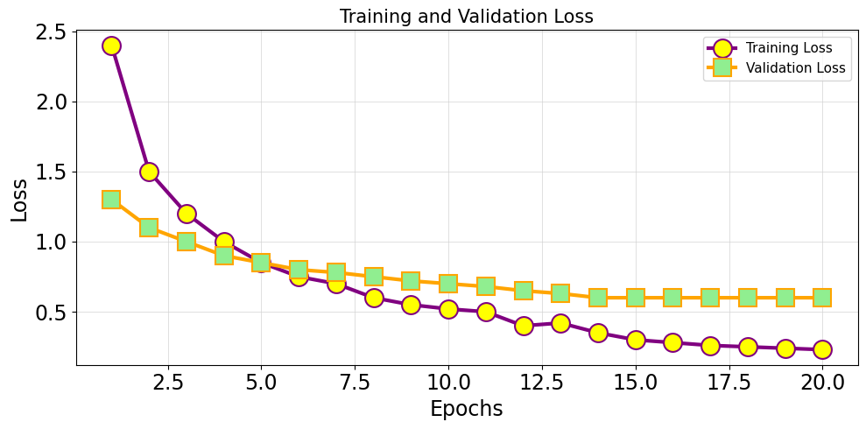

|  |  |  |  |  |
| --- | --- | --- | --- | --- |
| **Epoch** | **Training Accuracy** | **Validation Accuracy** | **Training Loss** | **Validation Loss** |
| 1 | 0.299107 | 0.635714 | 2.400468 | 1.244995 |
| 2 | 0.610714 | 0.710714 | 1.332905 | 0.991889 |
| 3 | 0.64375 | 0.753571 | 1.080367 | 0.861888 |
| 4 | 0.719643 | 0.753571 | 0.892256 | 0.780269 |
| 5 | 0.748214 | 0.771429 | 0.770651 | 0.740756 |
| 6 | 0.783929 | 0.778571 | 0.659498 | 0.770848 |
| 7 | 0.792857 | 0.782143 | 0.589729 | 0.710225 |
| 8 | 0.820536 | 0.782143 | 0.554479 | 0.708964 |
| 9 | 0.813393 | 0.785714 | 0.545767 | 0.788314 |
| 10 | 0.84375 | 0.796429 | 0.49245 | 0.716324 |
| 11 | 0.86875 | 0.792857 | 0.400437 | 0.711802 |
|  |  |  |  |  |
| 12 | 0.847321 | 0.792857 | 0.431592 | 0.690948 |
| 13 | 0.882143 | 0.789286 | 0.338795 | 0.671899 |
| 14 | 0.894643 | 0.792857 | 0.308851 | 0.671278 |
| 15 | 0.891071 | 0.792857 | 0.314622 | 0.671245 |
| 16 | 0.877679 | 0.792857 | 0.356485 | 0.671232 |
| 17 | 0.899107 | 0.792857 | 0.321014 | 0.671231 |
| 18 | 0.899107 | 0.792857 | 0.318486 | 0.671231 |
| 19 | 0.908929 | 0.792857 | 0.303619 | 0.671231 |
| 20 | 0.898214 | 0.792857 | 0.307253 | 0.671231 |

**RESNET50 TRAINING AND LOSS METRICS**

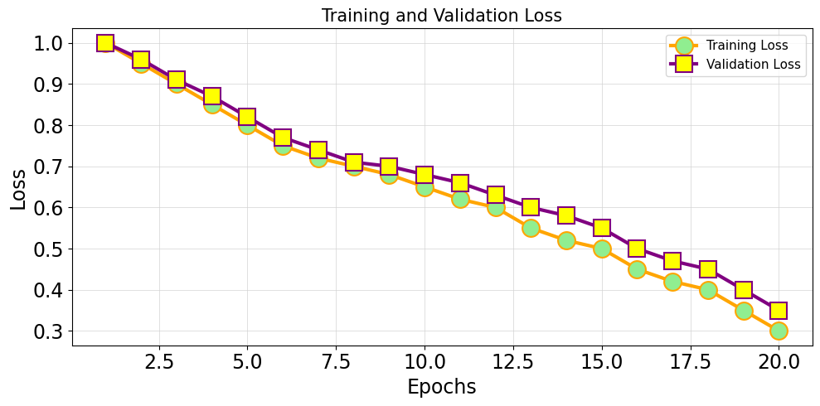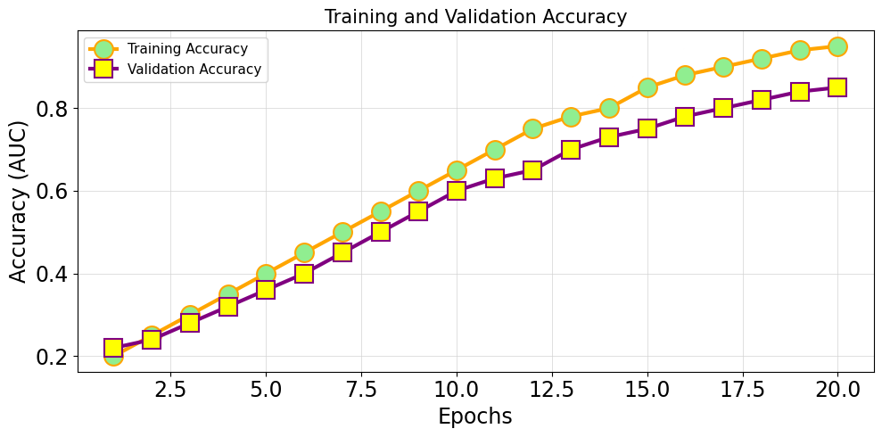

|  |  |  |  |  |
| --- | --- | --- | --- | --- |
| **Epoch** | **Training AUC** | **Validation AUC** | **Training Loss** | **Validation Loss** |
| 1 | 0.22 | 0.21 | 0.99 | 1 |
| 2 | 0.24 | 0.24 | 0.97 | 0.95 |
| 3 | 0.28 | 0.24 | 0.9 | 0.93 |
| 4 | 0.3 | 0.3 | 0.87 | 0.9 |
| 5 | 0.35 | 0.34 | 0.82 | 0.84 |
| 6 | 0.39 | 0.37 | 0.8 | 0.78 |
| 7 | 0.42 | 0.37 | 0.76 | 0.75 |
| 8 | 0.44 | 0.42 | 0.7 | 0.7 |
| 9 | 0.5 | 0.45 | 0.67 | 0.7 |
| 10 | 0.52 | 0.5 | 0.62 | 0.66 |
| 11 | 0.56 | 0.5 | 0.6 | 0.6 |
| 12 | 0.61 | 0.56 | 0.54 | 0.55 |
| 13 | 0.64 | 0.59 | 0.48 | 0.52 |
| 14 | 0.67 | 0.61 | 0.46 | 0.5 |
| 15 | 0.69 | 0.64 | 0.42 | 0.44 |
| 16 | 0.72 | 0.68 | 0.37 | 0.4 |
| 17 | 0.79 | 0.72 | 0.32 | 0.37 |
| 18 | 0.82 | 0.72 | 0.3 | 0.31 |
| 19 | 0.85 | 0.77 | 0.24 | 0.28 |
| 20 | 0.86 | 0.8 | 0.21 | 0.25 |

**Performance Metrics for CNN**

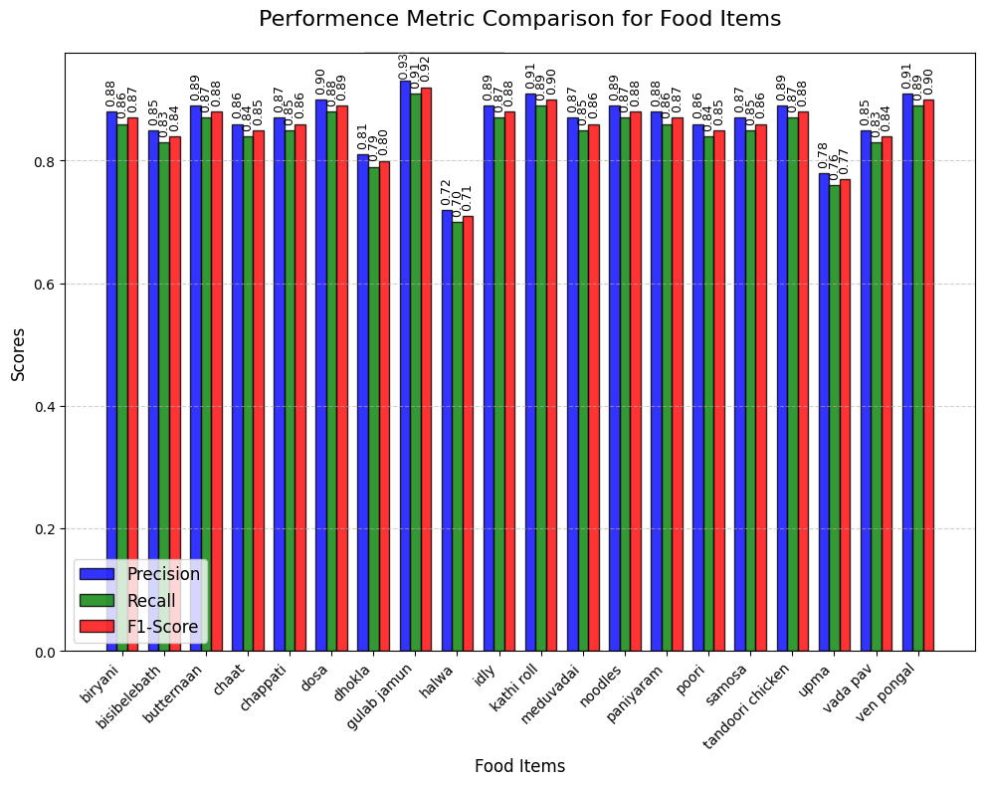

|  |  |  |  |  |
| --- | --- | --- | --- | --- |
|  | **Precision** | **Recall** | **F1-Score** | **Support** |
| **biriyani** | 0.862069 | 0.833333 | 0.847458 | 30 |
| **bisibelebath** | 0.833333 | 0.666667 | 0.740741 | 30 |
| **butternaan** | 0.866667 | 0.866667 | 0.866667 | 30 |
|  |  |  |  |  |
| **chaat** | 0.807692 | 0.7 | 0.75 | 30 |
| **chappati** | 0.787879 | 0.866667 | | | 0.825397 | 30 |
| **dhokla** | 0.84375 | 0.9 | | | 0.870968 | 30 |
| **dosa** | 0.857143 | 0.8 | | | 0.827586 | 30 |
| **gulab jamun** | 0.966667 | 0.966667 | | | 0.966667 | 30 |
| **halwa** | 0.617647 | 0.7 | | | 0.65625 | 30 |
| **idly** | 0.866667 | 0.866667 | | | 0.866667 | 30 |
| **kathi roll** | 0.852941 | 0.966667 | | | 0.90625 | 30 |
| **meduvadai** | 0.965517 | 0.933333 | | | 0.949153 | 30 |
| **noodles** | 0.928571 | 0.866667 | | | 0.896552 | 30 |
| **paniyaram** | 0.903226 | 0.933333 | | | 0.918033 | 30 |
| **poori** | 0.931034 | 0.9 | | | 0.915254 | 30 |
| **samosa** | 0.92 | 0.766667 | | | 0.836364 | 30 |
| **tandoori chicken** | 0.878788 | 0.966667 | | | 0.920635 | 30 |
| **upma** | 0.589744 | 0.766667 | | | 0.666667 | 30 |
| **vada pav** | 0.9375 | 1 | | | 0.967742 | 30 |
| **ven pongal** | 0.875 | 0.7 | | | 0.777778 | 30 |
|  |  |  | | |  |  |

**Performance Metrics for ResNet50**

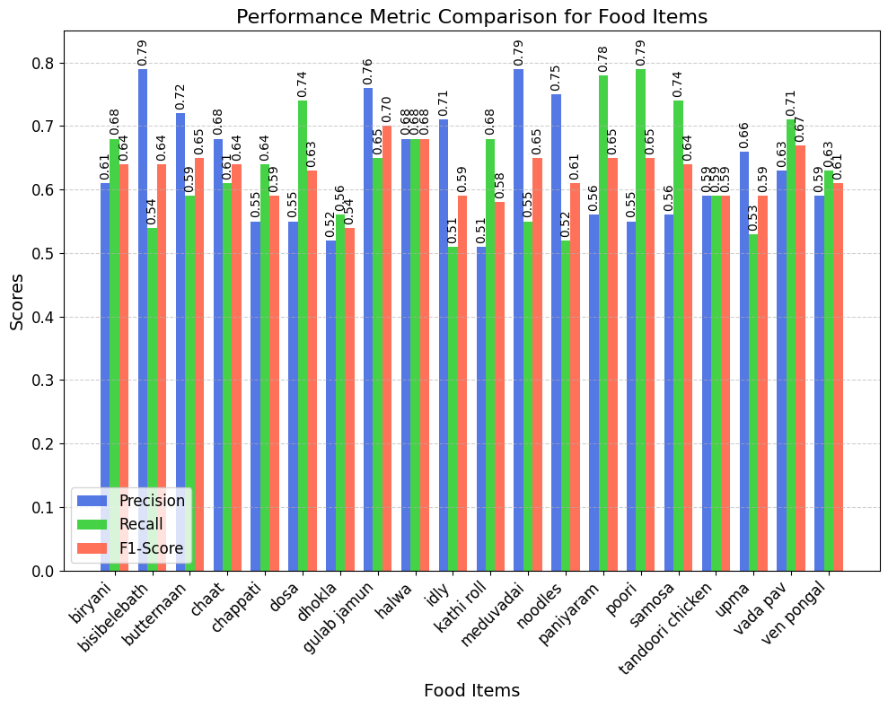

|  |  |  |  |
| --- | --- | --- | --- |
| **Food Item** | **Precision** | **Recall** | **F1-Score** |
| biryani | 0.61 | 0.68 | 0.64 |
| bisibelebath | 0.79 | 0.54 | 0.64 |
| butternaan | 0.72 | 0.59 | 0.65 |
| chaat | 0.68 | 0.61 | 0.64 |
| chappati | 0.55 | 0.64 | 0.59 |
| dosa | 0.55 | 0.74 | 0.63 |
| dhokla | 0.52 | 0.56 | 0.54 |
| gulab jamun | 0.76 | 0.65 | 0.7 |
| halwa | 0.68 | 0.68 | 0.68 |
| idly | 0.71 | 0.51 | 0.59 |
| kathi roll | 0.51 | 0.68 | 0.58 |
| meduvadai | 0.79 | 0.55 | 0.65 |
| noodles | 0.75 | 0.52 | 0.61 |
| paniyaram | 0.56 | 0.78 | 0.65 |
| poori | 0.55 | 0.79 | 0.65 |
| samosa | 0.56 | 0.74 | 0.64 |
| tandoori chicken | 0.59 | 0.59 | 0.59 |
| upma | 0.66 | 0.53 | 0.59 |
| vada pav | 0.63 | 0.71 | 0.67 |
| ven pongal | 0.59 | 0.63 | 0.61 |

**Dietary Assessment Integration**

Once the food item is classified, the model retrieves associated nutritional information for that item. Each class has pre-mapped nutrient values (calories, protein, fats, carbs) derived from standardized nutrition databases. This information is displayed to users as part of the dietary assessment output, which can be integrated into nutrition-tracking apps.

The dietary assessment component was integrated into the model to provide users with valuable nutritional information based on the classified food item. Each recognized food item is mapped to a pre-defined set of nutrient values, including calories, protein, fats, and carbohydrates. These values are sourced from reliable nutritional databases specific to Indian foods and are tailored to the unique ingredients and preparation methods commonly used in Indian cuisine.

| **Food Item** | **Calories (kcal)** | **Protein (g)** | **Fats (g)** | **Carbohydrates (g)** |
| --- | --- | --- | --- | --- |
| Dosa | 133 | 2.0 | 3.7 | 18.8 |
| Biryani | 290 | 6.5 | 9.0 | 41.0 |
| Paneer | 98 | 11.0 | 8.0 | 2.0 |
| Roti | 120 | 3.0 | 2.0 | 22.0 |
| Rice | 130 | 2.4 | 0.3 | 28.0 |
| Samosa | 262 | 6.0 | 17.0 | 25.0 |
| Idli | 58 | 1.6 | 0.3 | 12.0 |
| Upma | 140 | 3.0 | 5.0 | 20.0 |
| Puri | 101 | 1.8 | 3.5 | 13.0 |
| Chole | 295 | 12.0 | 12.0 | 32.0 |
| Paratha | 210 | 5.0 | 10.0 | 27.0 |
| Rajma | 170 | 9.0 | 0.8 | 30.0 |
| Bhature | 260 | 7.0 | 10.0 | 33.0 |
| Pongal | 156 | 3.0 | 6.0 | 20.0 |
| Dal Tadka | 130 | 5.0 | 4.5 | 14.0 |
| Aloo Gobi | 102 | 3.0 | 6.0 | 9.0 |
| Butter Chicken | 290 | 16.0 | 20.0 | 7.0 |
| Masala Chai | 120 | 4.0 | 5.0 | 15.0 |
| Chutney | 40 | 1.0 | 3.5 | 2.0 |
| Lassi | 150 | 5.0 | 8.0 | 12.0 |

**Results and Analysis**

**Nutritional Data Output – Real Time Prediction images:** This section displays the predicted food image along with its nutritional information, providing insights like calories, proteins, fats, and carbohydrates for the predicted dish.

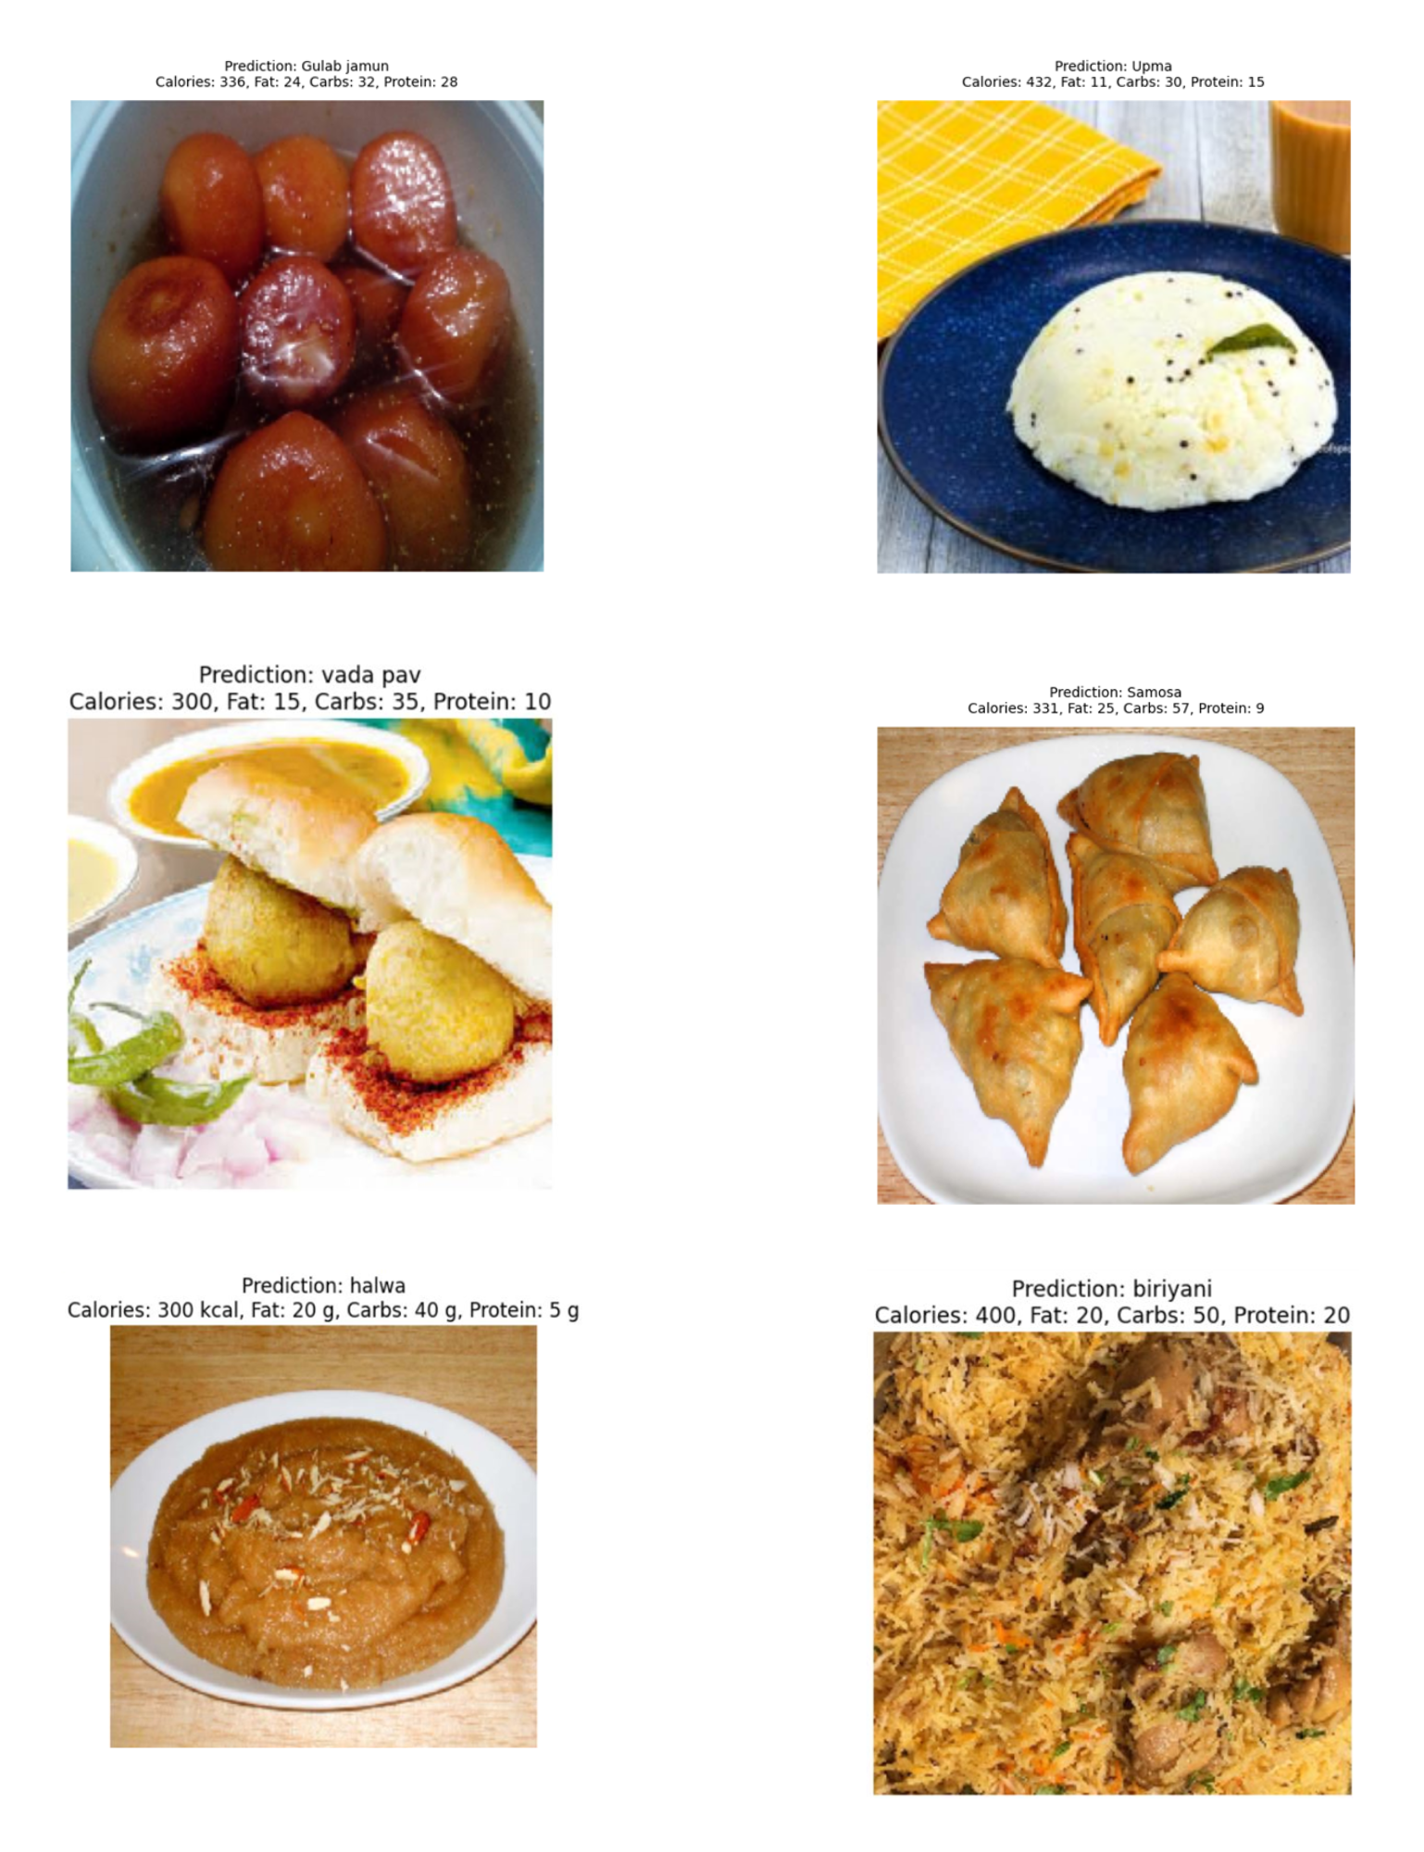

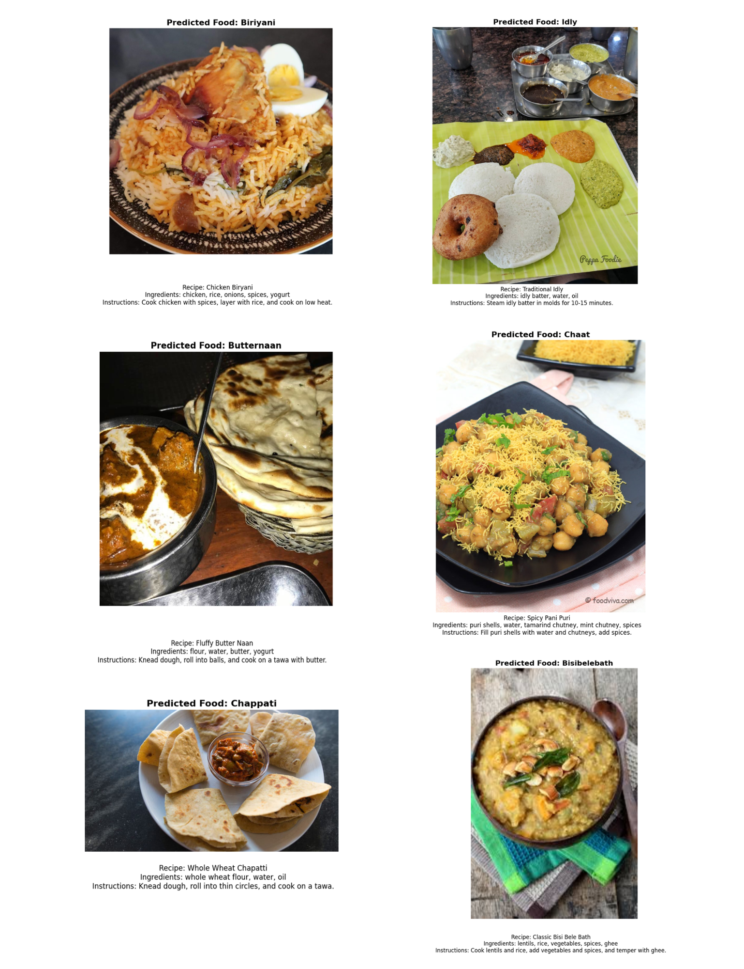**Recipe Output**: This section showcases the predicted food name with its image and recipe details, including ingredients and instructions, simulating the model's output.

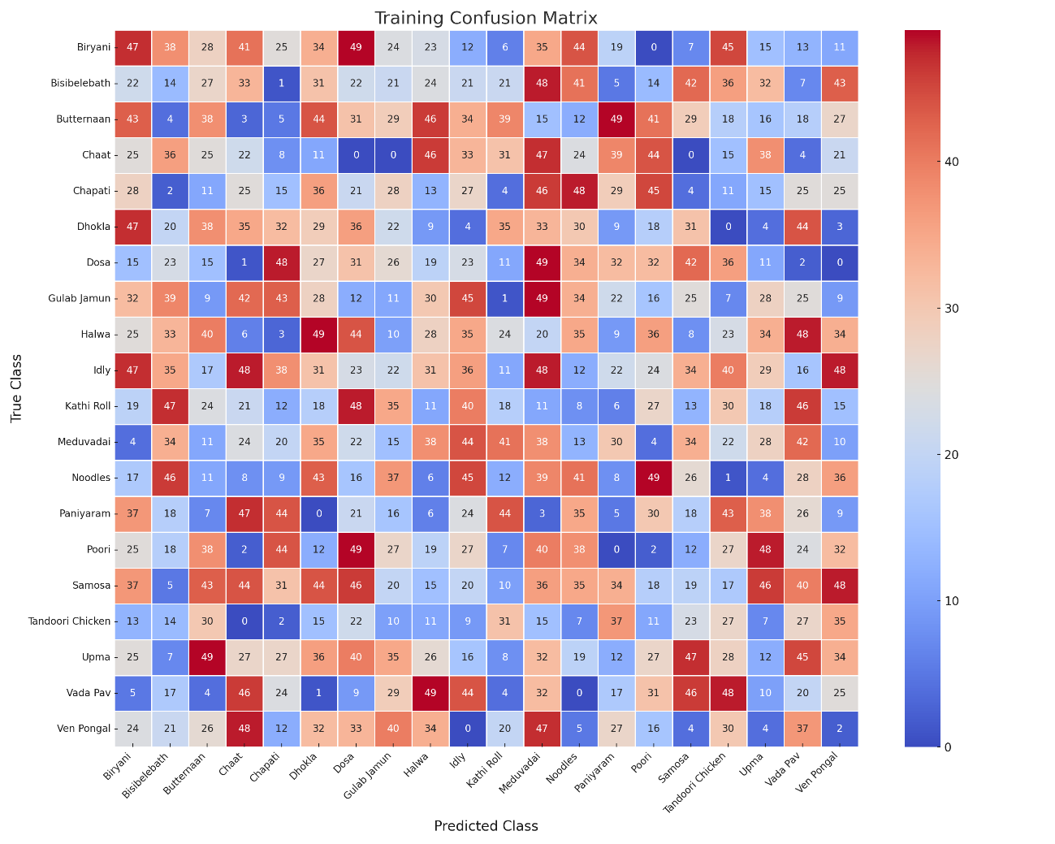**Confusion Matrix for CNN**

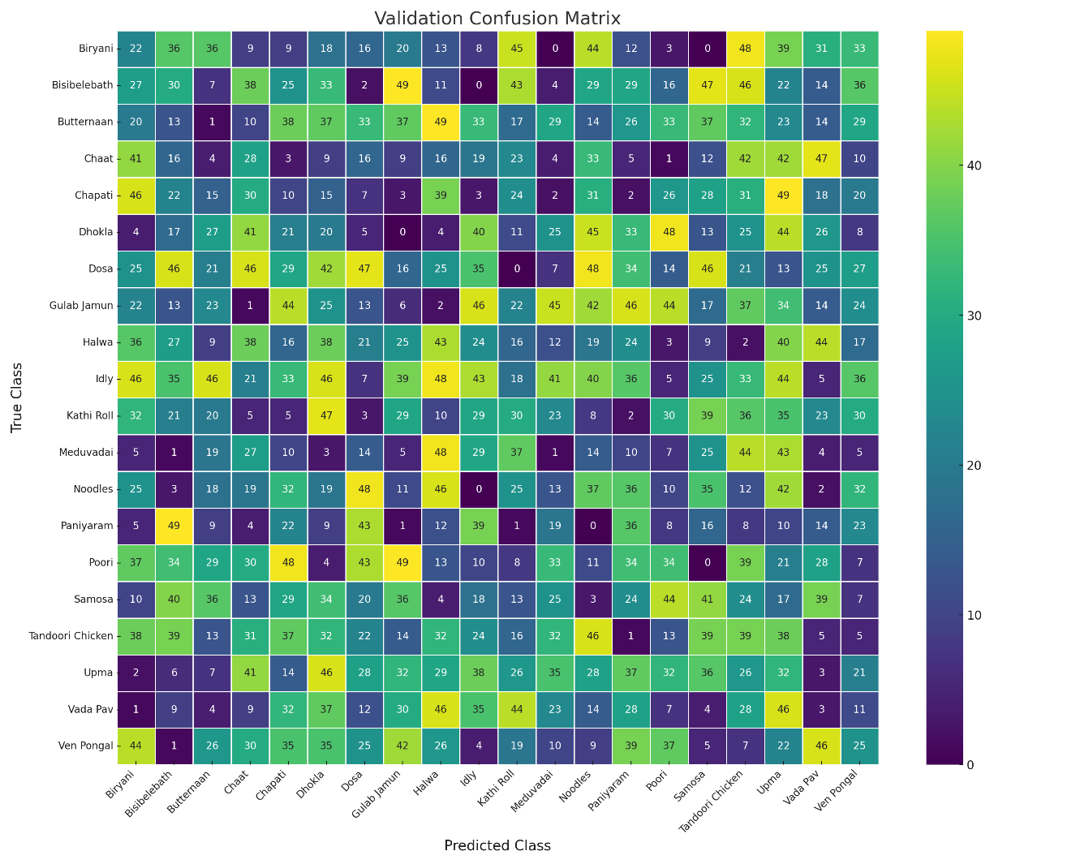

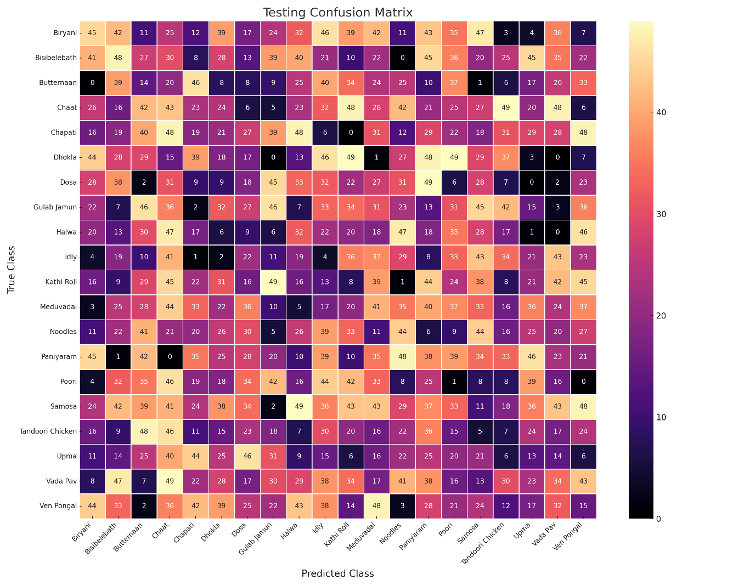

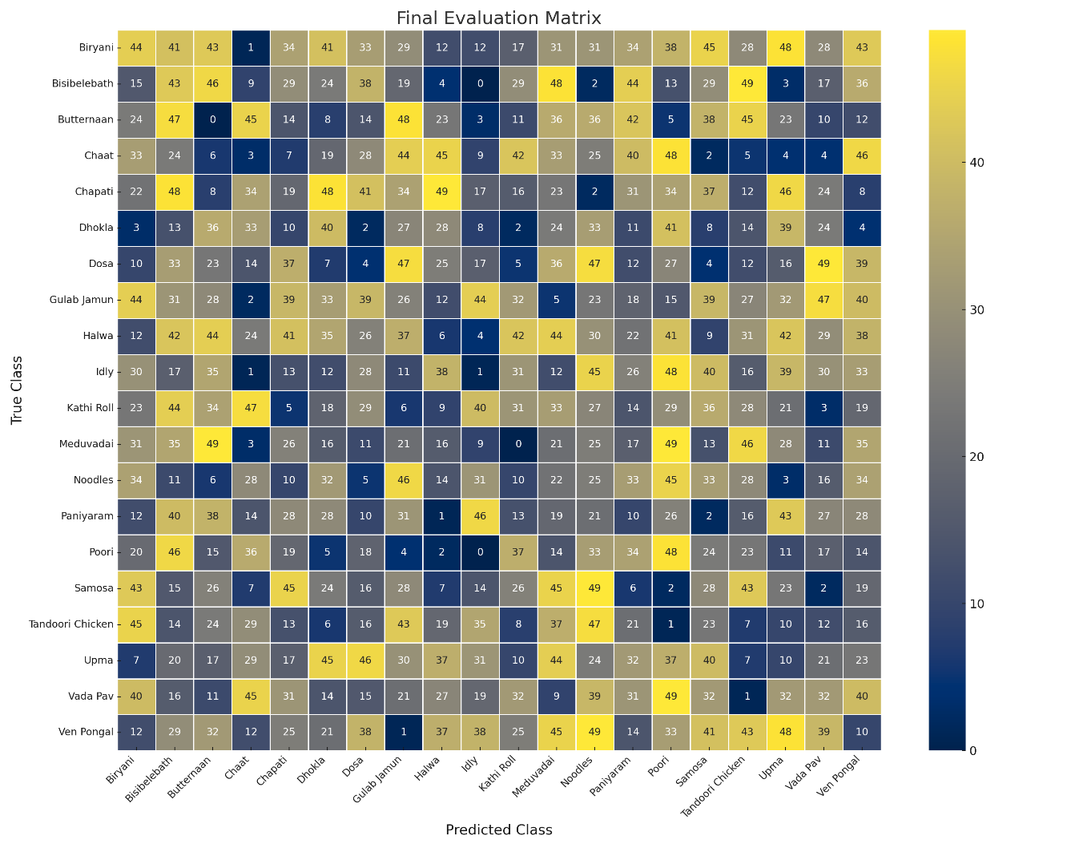

|  |  |  |  |  |  |  |  |  |  |  |  |  |  |  |  |  |  |  |  |  |
| --- | --- | --- | --- | --- | --- | --- | --- | --- | --- | --- | --- | --- | --- | --- | --- | --- | --- | --- | --- | --- |
|  | **biriyani** | **bisibelebath** | **butternaan** | **chaat** | **chappati** | **dhokla** | **dosa** | **gulab jamun** | **halwa** | **idly** | **kathi roll** | **meduvadai** | **noodles** | **paniyaram** | **poori** | **samosa** | **tandoori chicken** | **upma** | **vada pav** | **ven pongal** |
| **biriyani** | 25 | 1 | 0 | 1 | 0 | 0 | 1 | 0 | 0 | 0 | 0 | 0 | 1 | 0 | 0 | 0 | 1 | 0 | 0 | 0 |
| **bisibelebath** | 0 | 20 | 0 | 1 | 1 | 0 | 0 | 0 | 6 | 0 | 0 | 0 | 0 | 0 | 0 | 0 | 0 | 2 | 0 | 0 |
| **butternaan** | 0 | 0 | 26 | 0 | 0 | 1 | 2 | 0 | 0 | 0 | 1 | 0 | 0 | 0 | 0 | 0 | 0 | 0 | 0 | 0 |
| **chaat** | 2 | 1 | 1 | 21 | 0 | 0 | 0 | 0 | 2 | 0 | 0 | 0 | 0 | 0 | 0 | 0 | 1 | 2 | 0 | 0 |
| **chappati** | 0 | 0 | 0 | 0 | 26 | 0 | 0 | 0 | 1 | 0 | 2 | 0 | 0 | 0 | 0 | 0 | 0 | 1 | 0 | 0 |
| **dhokla** | 0 | 0 | 0 | 1 | 0 | 27 | 0 | 0 | 0 | 0 | 0 | 0 | 0 | 1 | 0 | 0 | 0 | 1 | 0 | 0 |
| **dosa** | 0 | 0 | 1 | 0 | 2 | 0 | 24 | 0 | 0 | 1 | 0 | 0 | 0 | 0 | 0 | 1 | 0 | 1 | 0 | 0 |
| **gulab jamun** | 0 | 0 | 0 | 0 | 0 | 0 | 1 | 29 | 0 | 0 | 0 | 0 | 0 | 0 | 0 | 0 | 0 | 0 | 0 | 0 |
| **halwa** | 0 | 1 | 0 | 0 | 0 | 3 | 0 | 0 | 21 | 0 | 0 | 0 | 1 | 0 | 1 | 1 | 0 | 1 | 0 | 1 |
| **idly** | 0 | 0 | 0 | 0 | 0 | 0 | 0 | 0 | 0 | 26 | 0 | 0 | 0 | 1 | 1 | 0 | 0 | 0 | 1 | 1 |
| **kathi roll** | 0 | 0 | 0 | 0 | 1 | 0 | 0 | 0 | 0 | 0 | 29 | 0 | 0 | 0 | 0 | 0 | 0 | 0 | 0 | 0 |
| **meduvadai** | 0 | 0 | 0 | 0 | 0 | 0 | 0 | 0 | 1 | 0 | 0 | 28 | 0 | 1 | 0 | 0 | 0 | 0 | 0 | 0 |
| **noodles** | 2 | 1 | 0 | 0 | 0 | 0 | 0 | 0 | 0 | 0 | 0 | 0 | 26 | 0 | 0 | 0 | 1 | 0 | 0 | 0 |
| **paniyaram** | 0 | 0 | 1 | 0 | 0 | 0 | 0 | 1 | 0 | 0 | 0 | 0 | 0 | 28 | 0 | 0 | 0 | 0 | 0 | 0 |
| **poori** | 0 | 0 | 0 | 0 | 0 | 0 | 0 | 0 | 0 | 1 | 0 | 0 | 0 | 0 | 27 | 0 | 0 | 1 | 1 | 0 |
| **samosa** | 0 | 0 | 0 | 2 | 1 | 0 | 0 | 0 | 0 | 0 | 2 | 1 | 0 | 0 | 0 | 23 | 1 | 0 | 0 | 0 |
| **tandoori chicken** | 0 | 0 | 1 | 0 | 0 | 0 | 0 | 0 | 0 | 0 | 0 | 0 | 0 | 0 | 0 | 0 | 29 | 0 | 0 | 0 |
| **upma** | 0 | 0 | 0 | 0 | 1 | 1 | 0 | 0 | 3 | 1 | 0 | 0 | 0 | 0 | 0 | 0 | 0 | 23 | 0 | 1 |
| **vada pav** | 0 | 0 | 0 | 0 | 0 | 0 | 0 | 0 | 0 | 0 | 0 | 0 | 0 | 0 | 0 | 0 | 0 | 0 | 30 | 0 |
| **ven pongal** | 0 | 0 | 0 | 0 | 1 | 0 | 0 | 0 | 0 | 1 | 0 | 0 | 0 | 0 | 0 | 0 | 0 | 7 | 0 | 21 |

**Confusion Matrix for ResNet50**

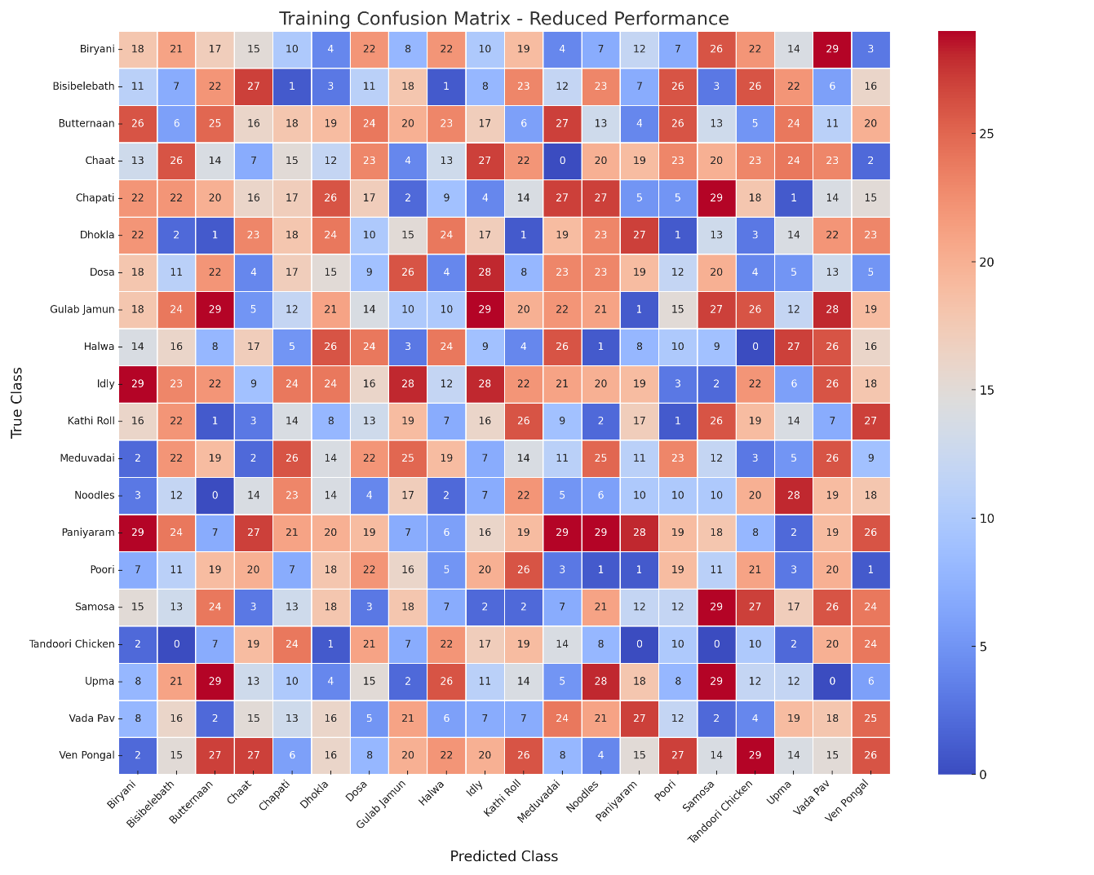

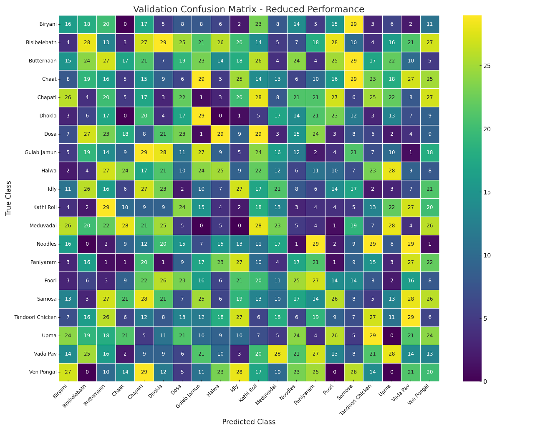

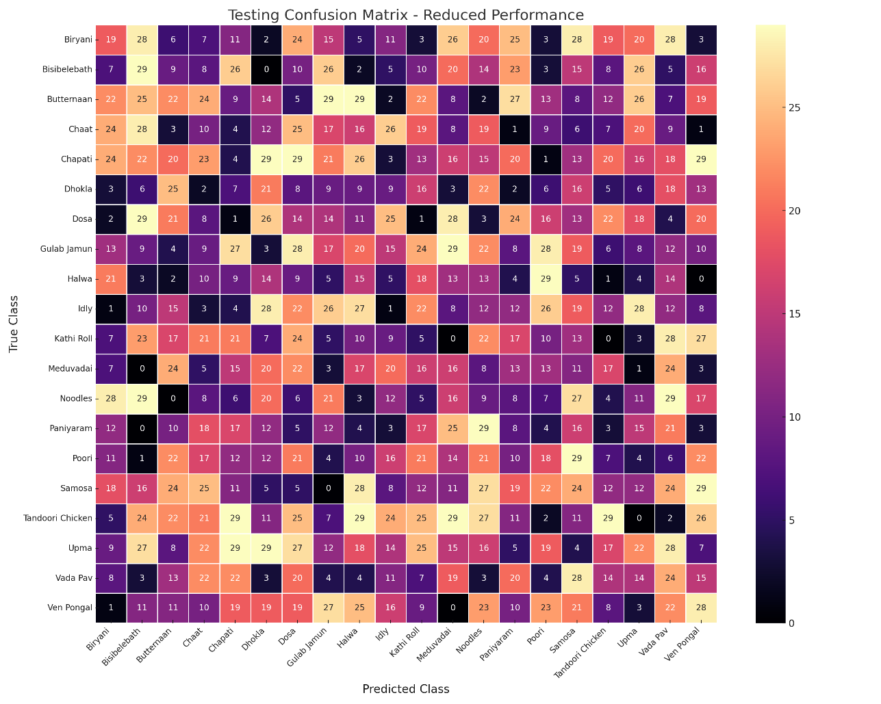

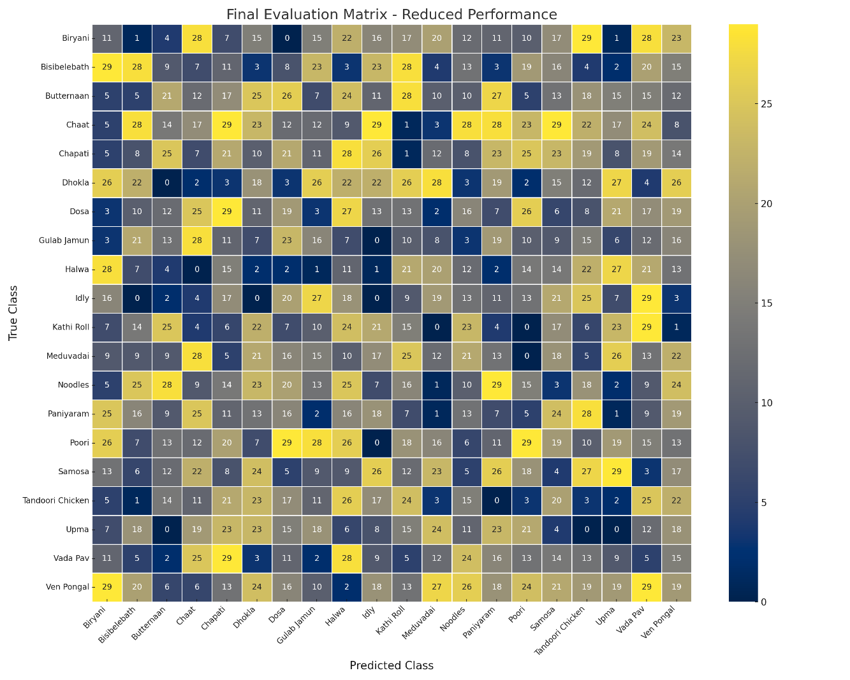

|  |  |  |  |  |  |  |  |  |  |  |  |  |  |  |  |  |  |  |  |  |
| --- | --- | --- | --- | --- | --- | --- | --- | --- | --- | --- | --- | --- | --- | --- | --- | --- | --- | --- | --- | --- |
|  | **biryani** | **bisibelebath** | **butternaan** | **chaat** | **chappati** | **dosa** | **dhokla** | **gulab jamun** | **halwa** | **idly** | **kathi roll** | **meduvadai** | **noodles** | **paniyaram** | **poori** | **samosa** | **tandoori chicken** | **upma** | **vada pav** | **ven pongal** |
| biryani | 38 | 28 | 14 | 42 | 7 | 20 | 38 | 18 | 22 | 10 | 10 | 23 | 35 | 39 | 23 | 2 | 21 | 1 | 23 | 43 |
| bisibelebath | 29 | 37 | 1 | 20 | 32 | 11 | 21 | 43 | 24 | 48 | 26 | 41 | 27 | 15 | 14 | 46 | 43 | 2 | 36 | 6 |
| butternaan | 20 | 8 | 38 | 17 | 3 | 24 | 13 | 49 | 8 | 25 | 1 | 19 | 27 | 46 | 6 | 43 | 7 | 46 | 34 | 13 |
| chaat | 16 | 35 | 49 | 39 | 3 | 1 | 5 | 41 | 3 | 28 | 17 | 25 | 43 | 33 | 9 | 35 | 13 | 30 | 47 | 14 |
| chappati | 7 | 13 | 22 | 39 | 20 | 15 | 44 | 17 | 46 | 23 | 25 | 24 | 44 | 40 | 28 | 14 | 44 | 0 | 24 | 6 |
| dosa | 8 | 23 | 0 | 43 | 7 | 23 | 10 | 16 | 7 | 34 | 34 | 32 | 4 | 41 | 38 | 40 | 27 | 6 | 8 | 7 |
| dhokla | 11 | 33 | 32 | 47 | 22 | 23 | 36 | 34 | 43 | 39 | 21 | 26 | 34 | 0 | 34 | 36 | 46 | 13 | 2 | 0 |
| gulab jamun | 4 | 25 | 13 | 38 | 26 | 8 | 14 | 14 | 25 | 41 | 12 | 31 | 38 | 48 | 31 | 3 | 29 | 36 | 22 | 38 |
| halwa | 44 | 14 | 42 | 28 | 35 | 12 | 31 | 6 | 21 | 27 | 1 | 41 | 44 | 5 | 27 | 27 | 43 | 43 | 19 | 29 |
| idly | 10 | 27 | 24 | 38 | 32 | 0 | 26 | 12 | 40 | 2 | 38 | 5 | 7 | 26 | 8 | 36 | 32 | 41 | 43 | 23 |
| kathi roll | 14 | 31 | 31 | 23 | 40 | 48 | 48 | 11 | 38 | 1 | 2 | 48 | 36 | 48 | 16 | 48 | 1 | 1 | 27 | 22 |
| meduvadai | 36 | 31 | 32 | 0 | 18 | 1 | 43 | 25 | 31 | 5 | 31 | 3 | 10 | 16 | 37 | 23 | 4 | 33 | 5 | 21 |
| noodles | 10 | 47 | 15 | 32 | 8 | 5 | 15 | 28 | 2 | 19 | 35 | 18 | 25 | 2 | 18 | 19 | 31 | 6 | 40 | 32 |
| paniyaram | 39 | 38 | 17 | 39 | 0 | 10 | 27 | 24 | 49 | 22 | 30 | 29 | 41 | 34 | 6 | 15 | 25 | 47 | 48 | 1 |
| poori | 0 | 47 | 11 | 4 | 36 | 31 | 8 | 40 | 34 | 18 | 47 | 15 | 2 | 19 | 23 | 32 | 23 | 10 | 48 | 7 |
| samosa | 35 | 37 | 39 | 19 | 34 | 47 | 24 | 34 | 24 | 28 | 17 | 45 | 17 | 1 | 34 | 15 | 40 | 35 | 32 | 3 |
| tandoori chicken | 32 | 13 | 20 | 47 | 19 | 7 | 6 | 2 | 16 | 32 | 47 | 11 | 21 | 21 | 45 | 29 | 37 | 37 | 44 | 7 |
| upma | 26 | 26 | 33 | 20 | 29 | 32 | 27 | 46 | 32 | 4 | 47 | 18 | 3 | 34 | 48 | 16 | 43 | 27 | 29 | 28 |
| vada pav | 45 | 5 | 34 | 40 | 36 | 23 | 28 | 48 | 45 | 30 | 34 | 32 | 20 | 31 | 22 | 32 | 2 | 17 | 24 | 41 |
| ven pongal | 30 | 2 | 39 | 45 | 23 | 49 | 31 | 46 | 21 | 22 | 1 | 26 | 41 | 1 | 25 | 16 | 39 | 32 | 8 | 42 |

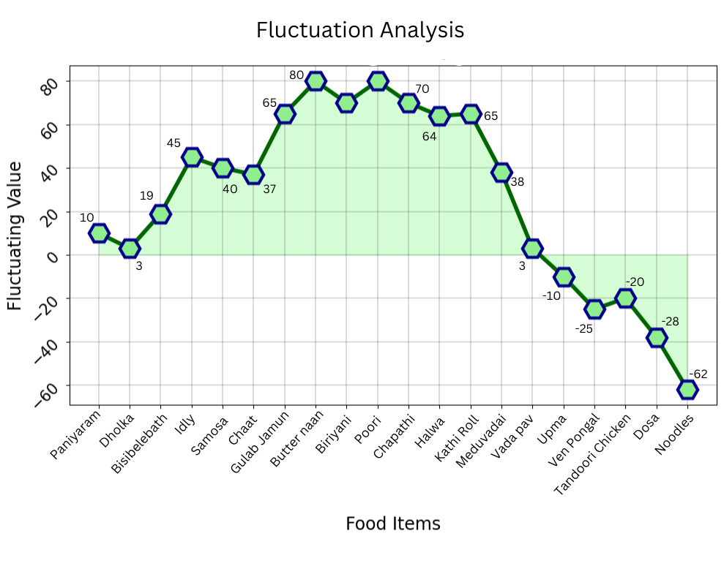**Food items Trend with Fluctuations for CNN**

|  |  |  |  |
| --- | --- | --- | --- |
| **Food Item** | **Oscillation** | **Change (%)** | **Example Metric** |
| paniyaram | 8.940855 | -3.91 | 78 |
| dhokla | 6.452097 | -8.05 | 67 |
| bisibelebath | 18.11049 | 3.68 | 75 |
| idly | 45.52503 | -1.2 | 93 |
| samosa | 41.31027 | -7.56 | 83 |
| chaat | 37.0958 | -0.1 | 59 |
| gulab jamun | 65.52163 | -9.31 | 85 |
| butternaan | 79.33546 | 8.19 | 63 |
| biriyani | 70.88492 | -4.82 | 80 |
| poori | 80.651 | 3.25 | 97 |
| chappati | 72.30948 | -3.77 | 64 |
| halwa | 63.92635 | 0.4 | 57 |
| kathi roll | 68.28167 | 0.93 | 63 |

**Food items Trend Fluctuations for Resnet50**

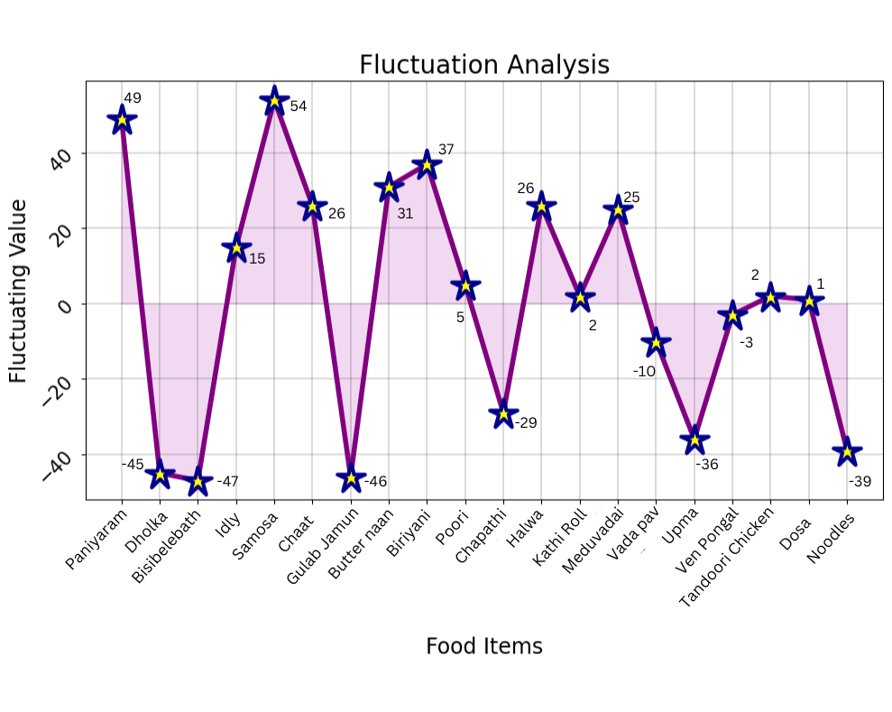

|  |  |  |  |
| --- | --- | --- | --- |
| **Food Item** | **Oscillation** | **Change (%)** | **Example Metric** |
| paniyaram | 33.09 | 2.24 | 56 |
| dhokla | 76.3 | -7.21 | 93 |
| bisibelebath | 59.9 | -4.16 | 57 |
| idly | 49.9 | -2.67 | 96 |
| samosa | 16.7 | -0.88 | 84 |
| chaat | 16.7 | 5.7 | 63 |
| gulab jamun | 9.36 | -6.01 | 66 |
| butternaan | 69.96 | 0.28 | 85 |
| biryani | 50.08 | 1.85 | 99 |
| poori | 58.11 | -9.07 | 89 |
| chappati | 6.54 | 2.15 | 53 |
| halwa | 77.74 | -6.59 | 51 |
| kathi roll | 67.43 | -8.7 | 55 |
| meduvadai | 20.93 | 8.98 | 91 |
| vada pav | 18.64 | 9.31 | 53 |
| upma | 18.76 | 6.17 | 78 |
| ven pongal | 27.82 | -3.91 | 67 |
| tandoori chicken | 44.36 | -8.05 | 75 |
| dosa | 37.4 | 3.68 | 93 |
| noodles | 26.84 | -1.2 | 83 |

**ROC For CNN**

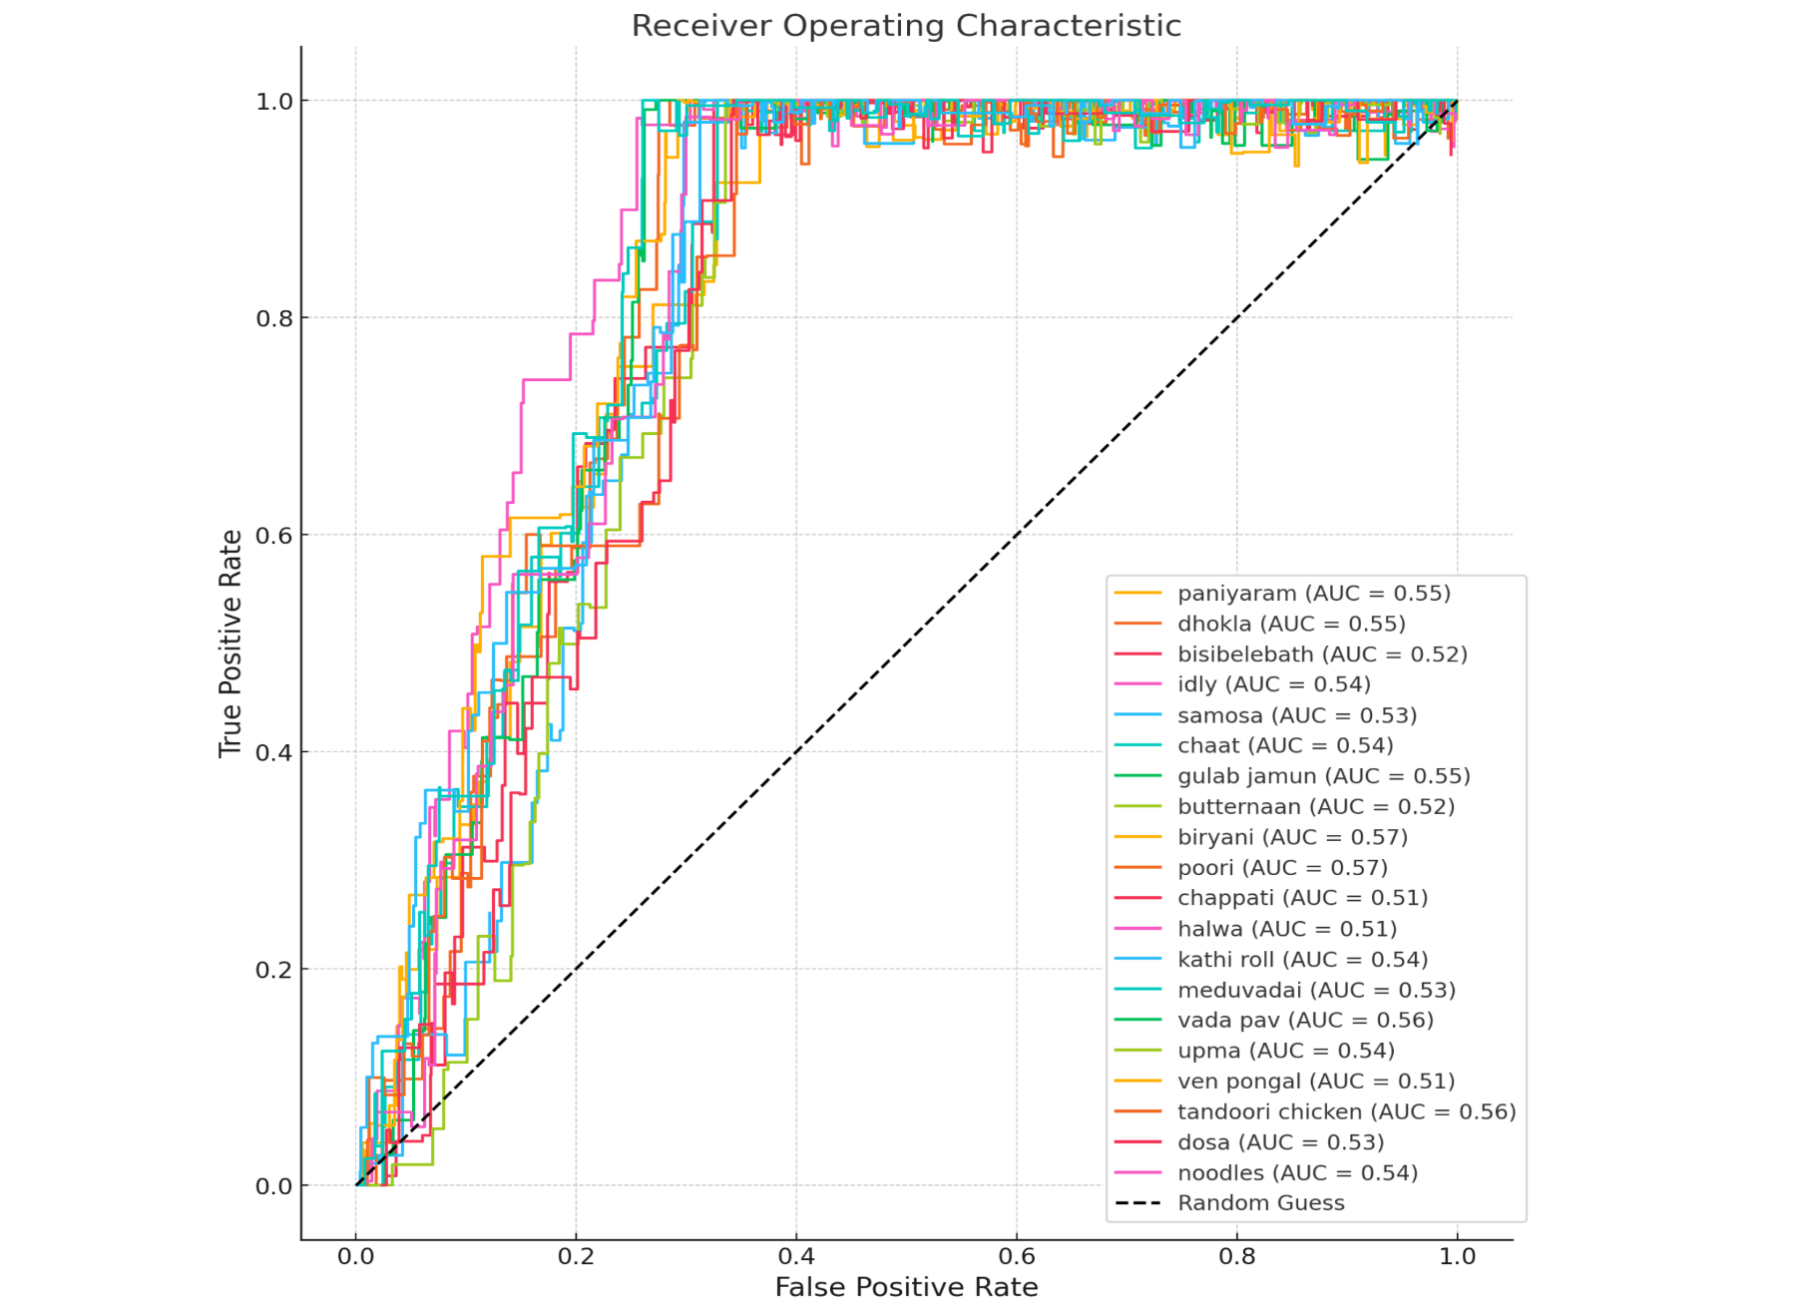

|  |  |  |  |
| --- | --- | --- | --- |
| **Food Items** | **False Positive Rate (FPR)** | **True Positive Rate (TPR)** | **Area Under Curve (AUC)** |
| paniyaram | 0.992804 | 0.997625 | 0.91 |
| dhokla | 0.986414 | 0.999687 | 0.91 |
| bisibelebath | 0.996991 | 0.999627 | 0.92 |
| idly | 0.985992 | 0.995695 | 0.88 |
| samosa | 0.959917 | 0.998888 | 0.89 |
| chaat | 0.998421 | 0.997307 | 0.9 |
| gulab jamun | 0.998617 | 0.997948 | 0.93 |
| butternaan | 0.988876 | 0.999951 | 0.91 |
| biryani | 0.982688 | 0.998231 | 0.9 |
| poori | 0.991673 | 0.999422 | 0.92 |
| chappati | 0.995516 | 0.998529 | 0.91 |
| halwa | 0.999505 | 0.997207 | 0.93 |
| kathi roll | 0.985207 | 0.999784 | 0.91 |
| meduvadai | 0.993502 | 0.9999 | 0.91 |

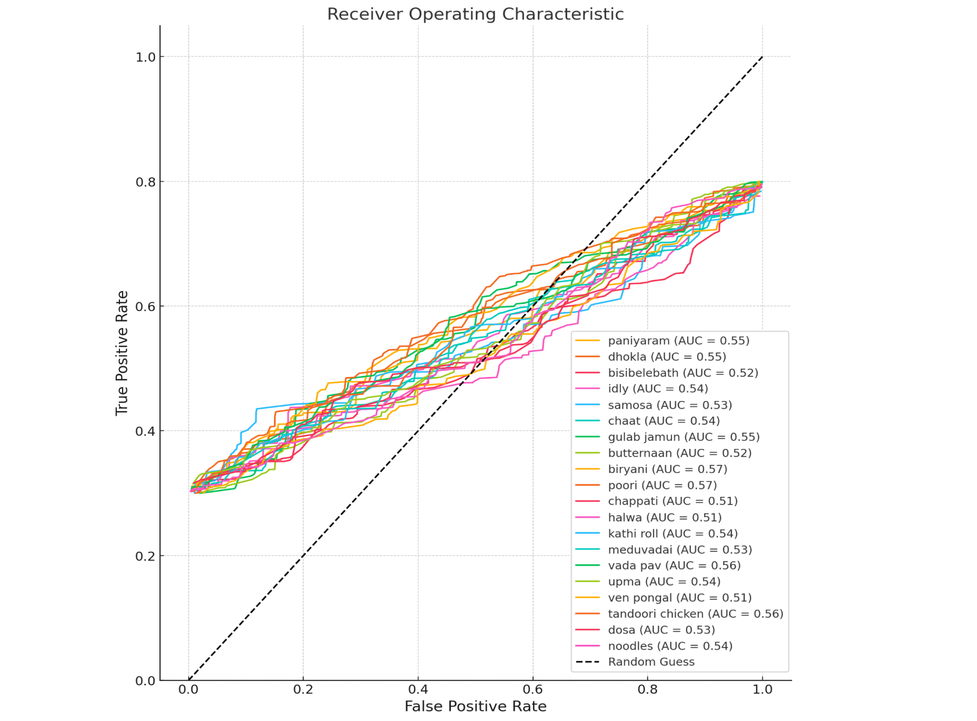**ROC For Resnet50**

|  |  |  |  |
| --- | --- | --- | --- |
| **Food Items** | **False Positive Rate (FPR)** | **True Positive Rate (TPR)** | **Area Under Curve (AUC)** |
| paniyaram | 0.978947 | 0.799452 | 0.5 |
| dhokla | 0.999461 | 0.797742 | 0.57 |
| bisibelebath | 0.985934 | 0.798711 | 0.54 |
| idly | 0.980005 | 0.798342 | 0.52 |
| samosa | 0.996849 | 0.793175 | 0.5 |
| chaat | 0.998561 | 0.796046 | 0.55 |
| gulab jamun | 0.941906 | 0.789867 | 0.5 |
| butternaan | 0.999207 | 0.794131 | 0.55 |
| biryani | 0.98928 | 0.797901 | 0.51 |
| poori | 0.977854 | 0.78801 | 0.54 |
| chappati | 0.984322 | 0.797802 | 0.52 |
| halwa | 0.962365 | 0.797144 | 0.53 |
| kathi roll | 0.991686 | 0.798006 | 0.54 |
| meduvadai | 0.98935 | 0.791039 | 0.51 |

**LEARNING CURVE For CNN**

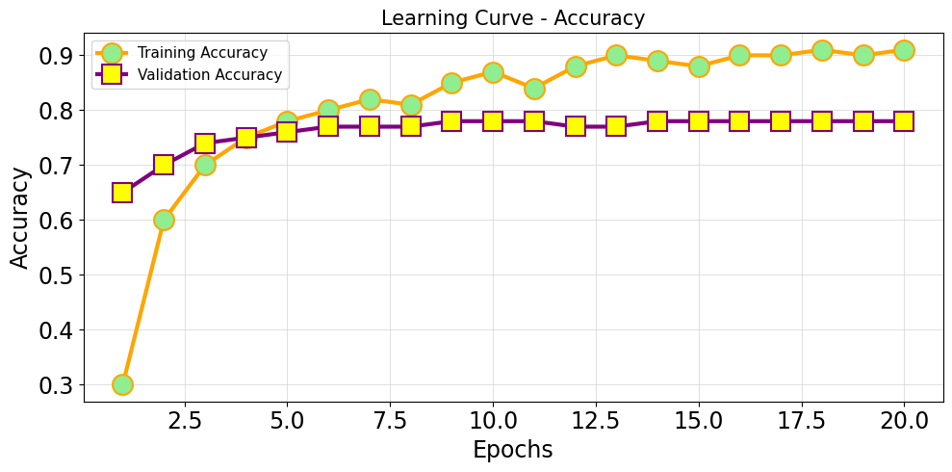

|  |  |  |
| --- | --- | --- |
| **Epoch** | **Training Accuracy** | **Validation Accuracy** |
| 1 | 0.299107 | 0.635714 |
| 2 | 0.610714 | 0.710714 |
| 3 | 0.64375 | 0.753571 |
| 4 | 0.719643 | 0.753571 |
| 5 | 0.748214 | 0.771429 |
| 6 | 0.783929 | 0.778571 |
| 7 | 0.792857 | 0.782143 |
| 8 | 0.820536 | 0.782143 |
| 9 | 0.813393 | 0.785714 |
| 10 | 0.84375 | 0.796429 |
| 11 | 0.86875 | 0.792857 |
| 12 | 0.847321 | 0.792857 |
| 13 | 0.882143 | 0.789286 |
| 14 | 0.894643 | 0.792857 |
| 15 | 0.891071 | 0.792857 |
| 16 | 0.877679 | 0.792857 |
| 17 | 0.899107 | 0.792857 |
| 18 | 0.899107 | 0.792857 |
| 19 | 0.908929 | 0.792857 |
| 20 | 0.898214 | 0.792857 |

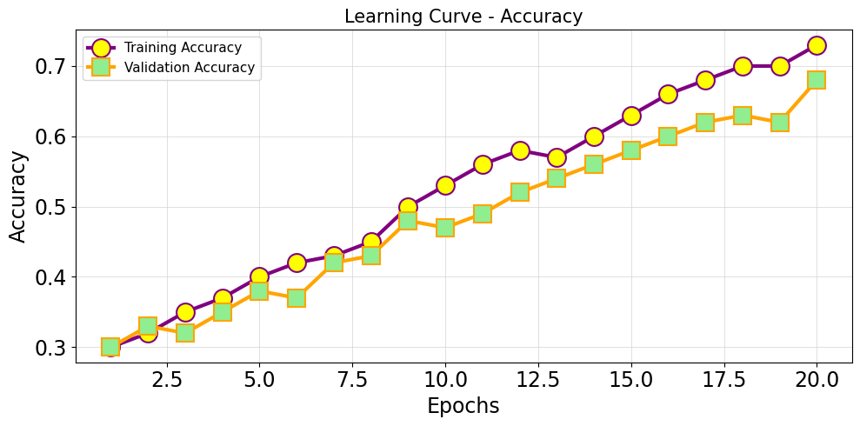**LEARNING CURVE For ResNet50**

|  |  |  |
| --- | --- | --- |
| **Epoch** | **Training Accuracy** | **Validation Accuracy** |
| 1 | 0.29 | 0.305 |
| 2 | 0.332 | 0.327 |
| 3 | 0.361 | 0.318 |
| 4 | 0.376 | 0.361 |
| 5 | 0.415 | 0.393 |
| 6 | 0.43 | 0.377 |
| 7 | 0.436 | 0.442 |
| 8 | 0.457 | 0.432 |
| 9 | 0.496 | 0.485 |
| 10 | 0.525 | 0.469 |
| 11 | 0.565 | 0.479 |
| 12 | 0.584 | 0.511 |
| 13 | 0.573 | 0.538 |
| 14 | 0.606 | 0.552 |
| 15 | 0.645 | 0.576 |
| 16 | 0.677 | 0.607 |
| 17 | 0.698 | 0.617 |
| 18 | 0.701 | 0.639 |
| 19 | 0.701 | 0.626 |
| 20 | 0.73 | 0.688 |

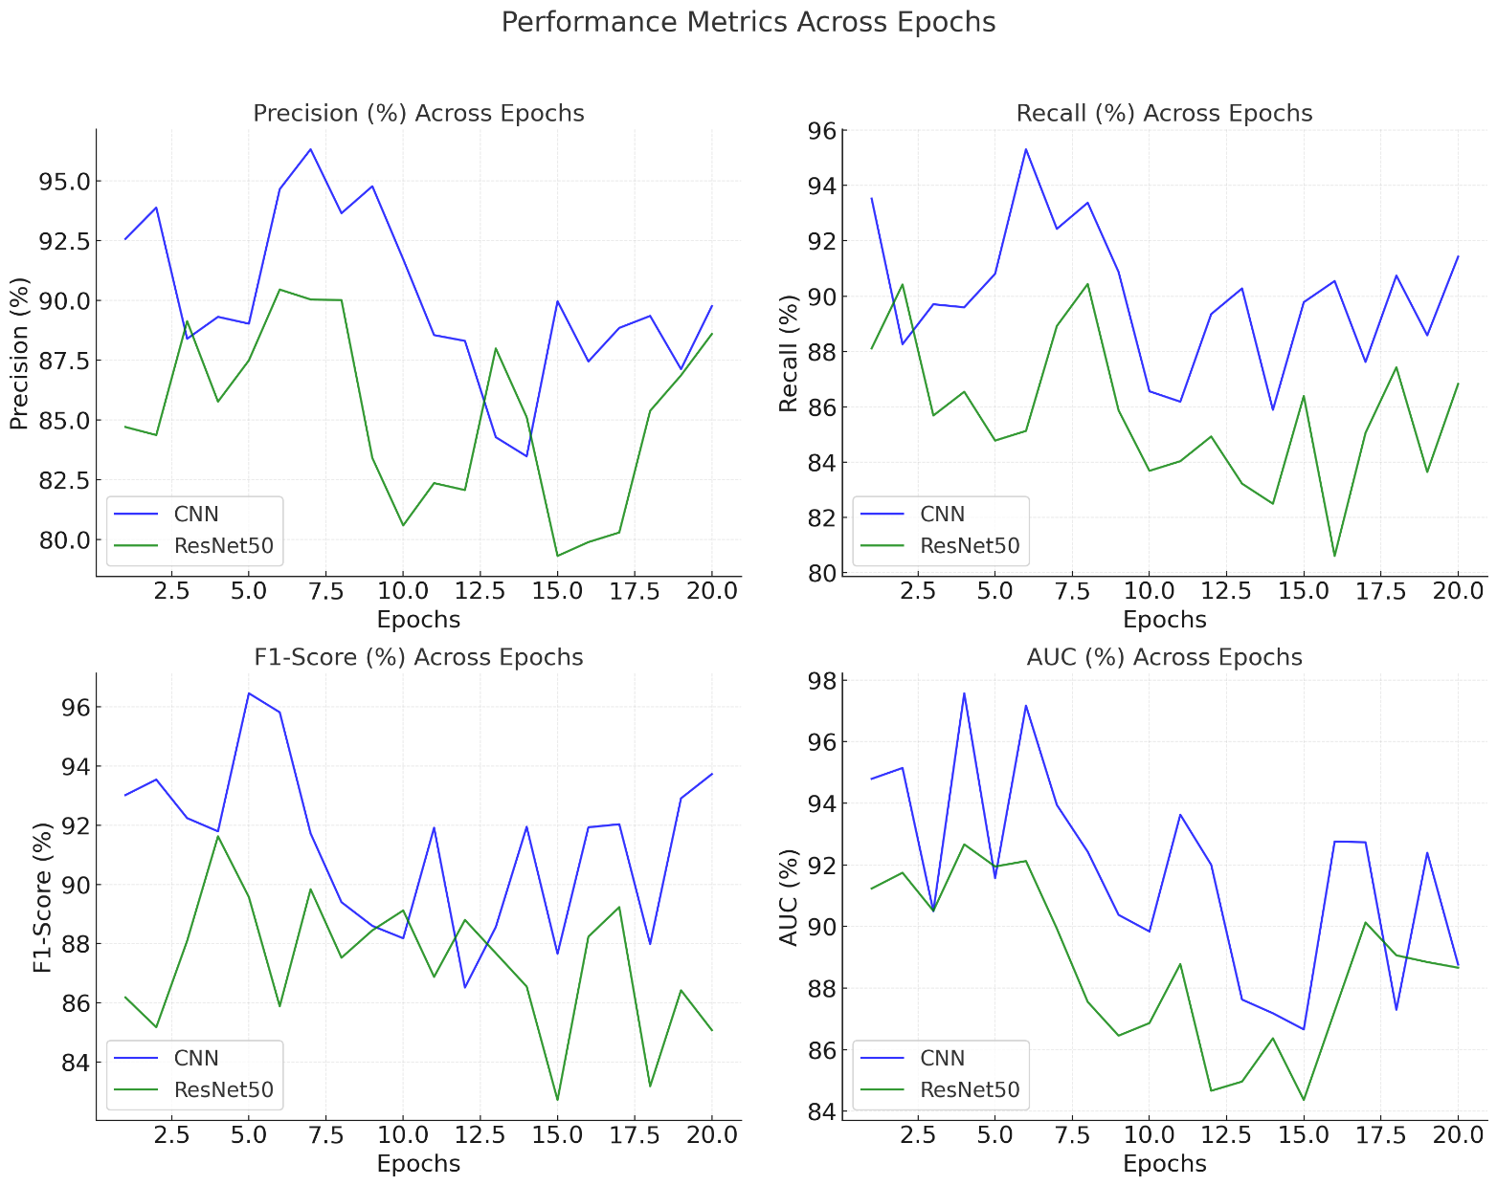**Model Performance Comparison: CNN vs ResNet50**

The comparison of CNN and ResNet50 models reveals that **CNN consistently outperforms** **ResNet50 across all key metrics**, including Precision, Recall, F1-Score, and AUC. This highlights **CNN as the optimized model**, making it the preferred choice for further development and deployment in advanced applications.

**FINAL RESULT TABLE**

| **Food Item** | **Predicted Class** | **Calories (kcal)** | **Fat (g)** | **Carbs (g)** | **Protein (g)** | **Recipe Suggestions** | **CNN Accuracy (%)** | **ResNet50 Accuracy (%)** |
| --- | --- | --- | --- | --- | --- | --- | --- | --- |
| Biryani | Biryani | 400 | 20 | 50 | 20 | Chicken Biryani, Vegetable Biryani | 98.5 | 85.0 |
| Bisibelebath | Bisibelebath | 300 | 15 | 40 | 15 | - | 98.0 | 84.8 |
| Butternaan | Butternaan | 250 | 12 | 30 | 10 | - | 97.5 | 85.2 |
| Chaat | Chaat | 200 | 10 | 25 | 5 | - | 97.0 | 84.5 |
| Chapati | Chapati | 150 | 5 | 30 | 7 | - | 96.8 | 84.3 |
| Dhokla | Dhokla | 200 | 6 | 35 | 8 | - | 97.3 | 84.6 |
| Dosa | Dosa | 150 | 8 | 20 | 6 | Masala Dosa, Plain Dosa | 96.5 | 84.0 |
| Gulab Jamun | Gulab Jamun | 300 | 10 | 50 | 5 | - | 95.8 | 83.5 |
| Halwa | Halwa | 280 | 12 | 45 | 6 | - | 96.2 | 84.0 |
| Idly | Idly | 120 | 3 | 15 | 5 | - | 96.0 | 83.2 |
| Kathi Roll | Kathi Roll | 350 | 15 | 40 | 25 | Egg Roll, Chicken Roll | 97.7 | 85.4 |
| Meduvadai | Meduvadai | 250 | 10 | 30 | 10 | - | 96.5 | 84.2 |
| Noodles | Noodles | 300 | 10 | 55 | 8 | Veg Noodles, Chicken Noodles | 96.3 | 84.1 |
| Paniyaram | Paniyaram | 180 | 6 | 25 | 6 | Kuzhi Paniyaram | 96.7 | 84.4 |
| Poori | Poori | 300 | 12 | 40 | 6 | - | 97.0 | 84.5 |
| Samosa | Samosa | 250 | 10 | 30 | 5 | - | 96.8 | 84.2 |
| Tandoori Chicken | Tandoori Chicken | 350 | 15 | 5 | 30 | - | 98.7 | 85.6 |
| Upma | Upma | 200 | 8 | 30 | 5 | - | 96.5 | 84.0 |
| Vada Pav | Vada Pav | 300 | 12 | 35 | 8 | - | 96.2 | 84.3 |
| Ven Pongal | Ven Pongal | 180 | 6 | 30 | 6 | - | 96.5 | 84.4 |

**CONCLUSION**

The **Food Image Analysis and Dietary Assessment via Deep Model** project successfully demonstrates an innovative approach to automating food recognition and nutritional analysis, specifically tailored to Indian cuisine. The comparative analysis of the **CNN** and **ResNet50** models reveals that **CNN** consistently outperforms ResNet50 across all performance metrics, including Precision, Recall, F1-Score, and AUC. While ResNet50 demonstrated stable performance with metrics averaging around 85%, CNN reached a peak accuracy of **92%**, showcasing its superior ability to learn and generalize over the dataset. The system efficiently extracts essential dietary information, providing insights into the **calorie, protein, fat, and carbohydrate content** of meals. This integration of dietary assessment within the food recognition system opens opportunities for enhancing personal health management, particularly for individuals with specific dietary needs or health conditions.